14dic2020

Video 3 de Diciembre Despliegue

Notas:

Manera de obtener la documentación de la implementación de FastAPI

<http://localhost:8000/redoc>

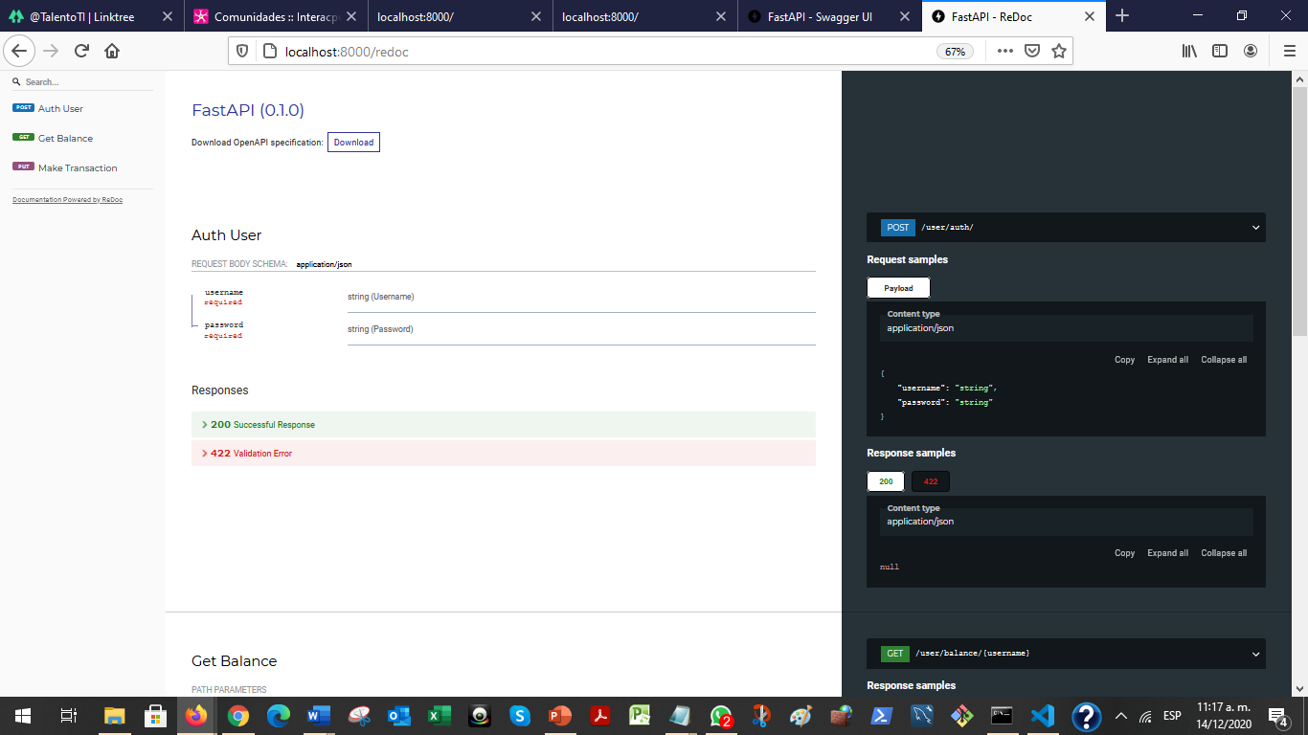

<http://localhost:8000/docs#/>

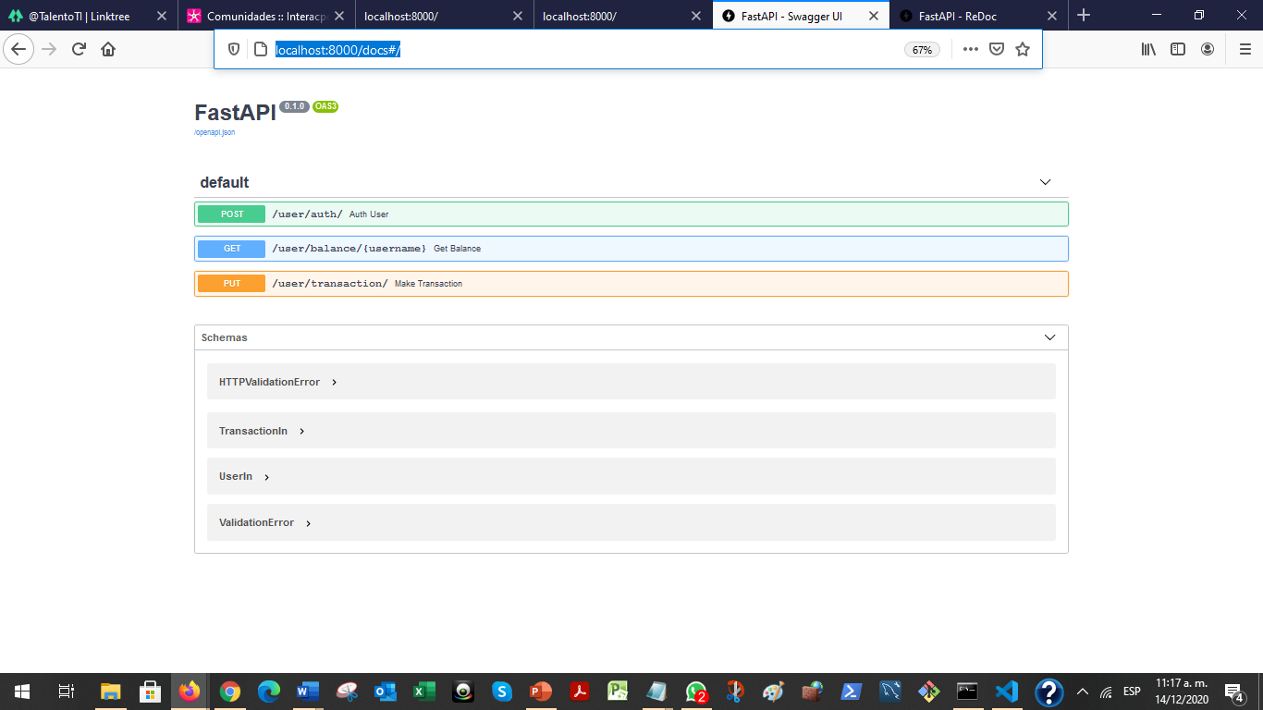

Para el despliegue se requiere tener Git en el equipo local y la cuenta de Github en la nube. Estos repositorios se conectarán con la herramienta de despliegue y habilitación para correr en Heroku.

<https://github.com/LUNARVAEZC> mi cuenta para los ejercicios.

Así se creo en Heroku para las pruebas:

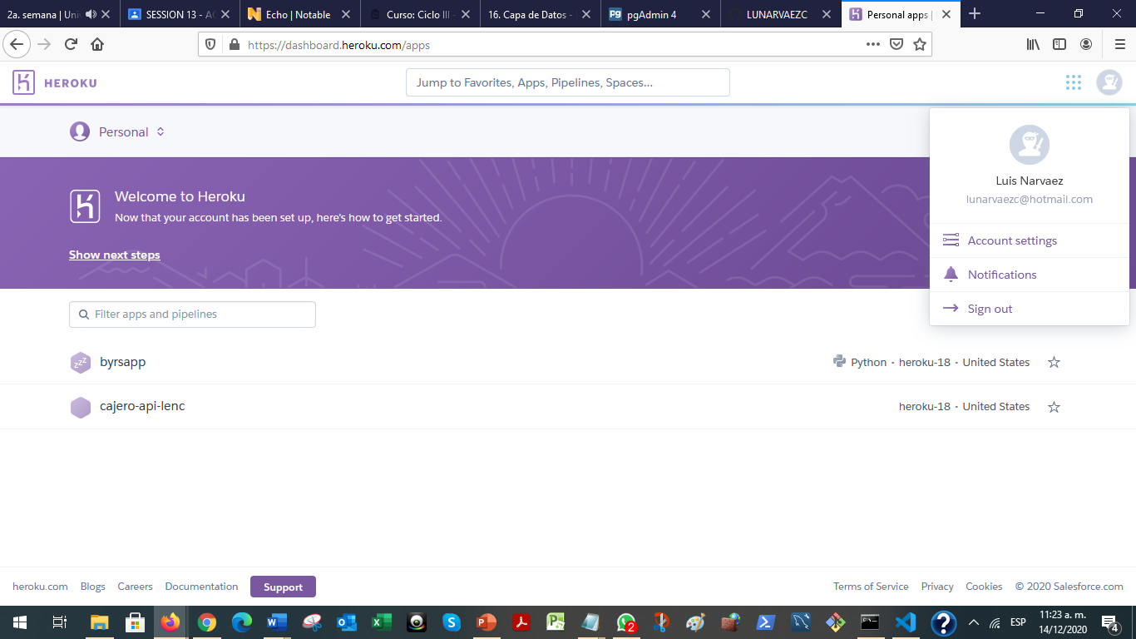

Se crea el repositorio en Github

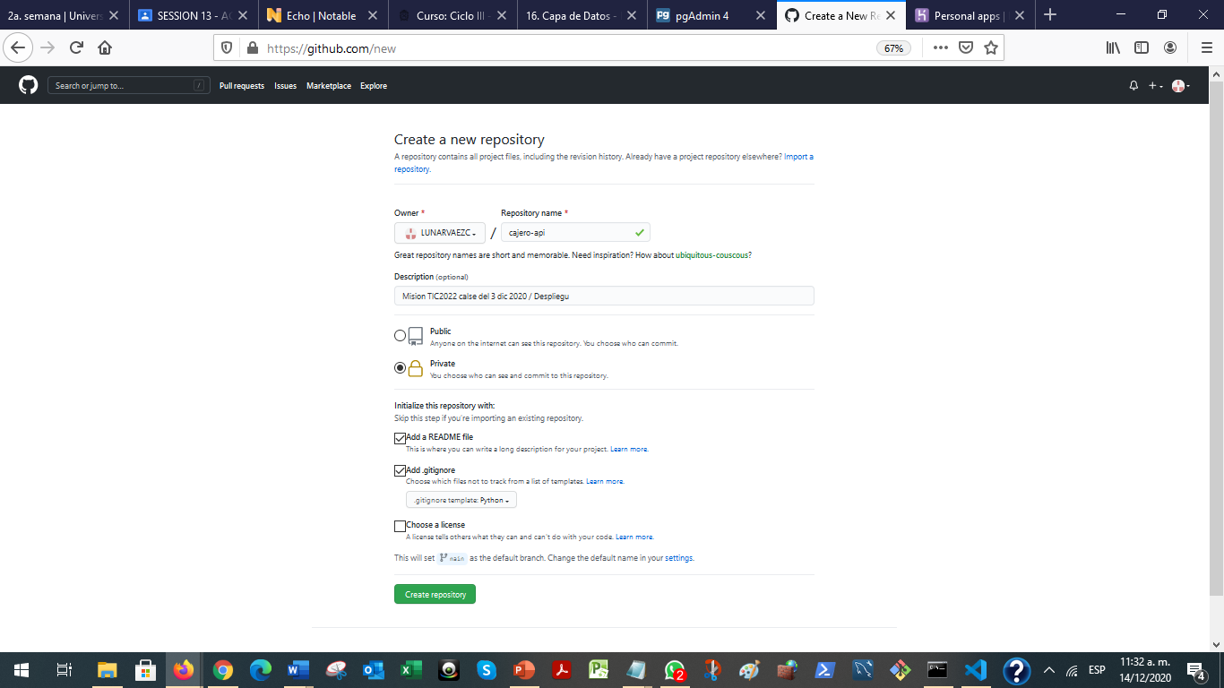

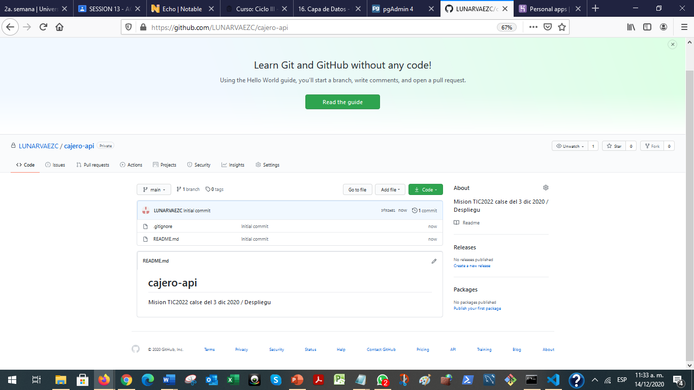

Se toma la URL que genera Github para el repositorio:

<https://github.com/LUNARVAEZC/cajero-api.git>

Lo anterior para clonar el repositorio de la carpeta local en su computador donde tiene el proyecto de Python que quiere subir a la nube con el control de versiones.

Como ya se tenía instalado el Git en el equipo se abre una consola de Gitbash y se ubica uno en la carpeta donde esta el proyecto a clonar:

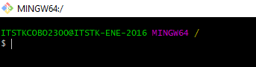

Observe que los comandos los asume como si fuera un Unix y el formato de separación de carpetas y subcarpetas es diferente a Windows y por eso no servía el comando CD:

**El backslash \ debío ser cambiado por slash /.**

ITSTKCOBO2300@ITSTK-ENE-2016 MINGW64 /

$ cd C:\Users\ITSTKCOBO2300\Documents\temp\cajero_api

bash: cd: C:UsersITSTKCOBO2300Documentstempcajero_api: No such file or directory

ITSTKCOBO2300@ITSTK-ENE-2016 MINGW64 /

$ dir

LICENSE.txt ReleaseNotes.html bin cmd dev etc git-bash.exe git-cmd.exe mingw64 proc tmp unins000.dat unins000.exe unins000.msg usr

ITSTKCOBO2300@ITSTK-ENE-2016 MINGW64 /

$ cd c:

ITSTKCOBO2300@ITSTK-ENE-2016 MINGW64 /c

$ cd C:\Users\ITSTKCOBO2300\Documents\temp\cajero_api

bash: cd: C:UsersITSTKCOBO2300Documentstempcajero_api: No such file or directory

ITSTKCOBO2300@ITSTK-ENE-2016 MINGW64 /c

$ cd Users/

ITSTKCOBO2300@ITSTK-ENE-2016 MINGW64 /c/Users

$ cd ITSTKCOBO2300/Documents/temp/cajero_api/

ITSTKCOBO2300@ITSTK-ENE-2016 MINGW64 ~/Documents/temp/cajero_api

Ahora si vamos a clonar con respecto a la URL del github:

ITSTKCOBO2300@ITSTK-ENE-2016 MINGW64 ~/Documents/temp/cajero_api

$ git clone https://github.com/LUNARVAEZC/cajero-api.git

Cloning into 'cajero-api'...

remote: Enumerating objects: 4, done.

remote: Counting objects: 100% (4/4), done.

remote: Compressing objects: 100% (4/4), done.

remote: Total 4 (delta 0), reused 0 (delta 0), pack-reused 0

Receiving objects: 100% (4/4), done.

Inicializar e incluir todos los archivos y verificar si han sido marcados:

Git init

Git add .

Git status

ITSTKCOBO2300@ITSTK-ENE-2016 MINGW64 ~/Documents/temp/cajero_api

$ git init

Initialized empty Git repository in C:/Users/ITSTKCOBO2300/Documents/temp/cajero_api/.git/

ITSTKCOBO2300@ITSTK-ENE-2016 MINGW64 ~/Documents/temp/cajero_api (master)

$ git add .

warning: adding embedded git repository: cajero-api

hint: You've added another git repository inside your current repository.

hint: Clones of the outer repository will not contain the contents of

hint: the embedded repository and will not know how to obtain it.

hint: If you meant to add a submodule, use:

hint:

hint: git submodule add <url> cajero-api

hint:

hint: If you added this path by mistake, you can remove it from the

hint: index with:

hint:

hint: git rm --cached cajero-api

hint:

hint: See "git help submodule" for more information.

ITSTKCOBO2300@ITSTK-ENE-2016 MINGW64 ~/Documents/temp/cajero_api (master)

$ git status

On branch master

No commits yet

Changes to be committed:

(use "git rm --cached <file>..." to unstage)

new file: .DS_Store

new file: .vscode/settings.json

new file: Notas de clase.docx

new file: __init__.py

new file: __pycache__/main.cpython-37.pyc

new file: __pycache__/main.cpython-38.pyc

new file: __pycache__/main.cpython-39.pyc

new file: cajero-api

new file: db/__init__.py

new file: db/__pycache__/__init__.cpython-37.pyc

new file: db/__pycache__/__init__.cpython-38.pyc

new file: db/__pycache__/__init__.cpython-39.pyc

new file: db/__pycache__/transaction_db.cpython-37.pyc

new file: db/__pycache__/transaction_db.cpython-38.pyc

new file: db/__pycache__/transaction_db.cpython-39.pyc

new file: db/__pycache__/user_db.cpython-37.pyc

new file: db/__pycache__/user_db.cpython-38.pyc

new file: db/__pycache__/user_db.cpython-39.pyc

new file: db/transaction_db.py

new file: db/user_db.py

new file: main.py

new file: models/__init__.py

new file: models/__pycache__/__init__.cpython-37.pyc

new file: models/__pycache__/__init__.cpython-38.pyc

new file: models/__pycache__/__init__.cpython-39.pyc

new file: models/__pycache__/transaction_models.cpython-37.pyc

new file: models/__pycache__/transaction_models.cpython-38.pyc

new file: models/__pycache__/transaction_models.cpython-39.pyc

new file: models/__pycache__/user_models.cpython-37.pyc

new file: models/__pycache__/user_models.cpython-38.pyc

new file: models/__pycache__/user_models.cpython-39.pyc

new file: models/transaction_models.py

new file: models/user_models.py

new file: readme-len.txt

new file: ~$tas de clase.docx

Luego se hace el commit para preparar todos los archivos para ser cargados:

ITSTKCOBO2300@ITSTK-ENE-2016 MINGW64 ~/Documents/temp/cajero_api (master)

$ git commit -m "primera versión proyecto fastAPI"

[master (root-commit) 6ec82fe] primera versión proyecto fastAPI

35 files changed, 285 insertions(+)

create mode 100644 .DS_Store

create mode 100644 .vscode/settings.json

create mode 100644 Notas de clase.docx

create mode 100644 __init__.py

create mode 100644 __pycache__/main.cpython-37.pyc

create mode 100644 __pycache__/main.cpython-38.pyc

create mode 100644 __pycache__/main.cpython-39.pyc

create mode 160000 cajero-api

create mode 100644 db/__init__.py

create mode 100644 db/__pycache__/__init__.cpython-37.pyc

create mode 100644 db/__pycache__/__init__.cpython-38.pyc

create mode 100644 db/__pycache__/__init__.cpython-39.pyc

create mode 100644 db/__pycache__/transaction_db.cpython-37.pyc

create mode 100644 db/__pycache__/transaction_db.cpython-38.pyc

create mode 100644 db/__pycache__/transaction_db.cpython-39.pyc

create mode 100644 db/__pycache__/user_db.cpython-37.pyc

create mode 100644 db/__pycache__/user_db.cpython-38.pyc

create mode 100644 db/__pycache__/user_db.cpython-39.pyc

create mode 100644 db/transaction_db.py

create mode 100644 db/user_db.py

create mode 100644 main.py

create mode 100644 models/__init__.py

create mode 100644 models/__pycache__/__init__.cpython-37.pyc

create mode 100644 models/__pycache__/__init__.cpython-38.pyc

create mode 100644 models/__pycache__/__init__.cpython-39.pyc

create mode 100644 models/__pycache__/transaction_models.cpython-37.pyc

create mode 100644 models/__pycache__/transaction_models.cpython-38.pyc

create mode 100644 models/__pycache__/transaction_models.cpython-39.pyc

create mode 100644 models/__pycache__/user_models.cpython-37.pyc

create mode 100644 models/__pycache__/user_models.cpython-38.pyc

create mode 100644 models/__pycache__/user_models.cpython-39.pyc

create mode 100644 models/transaction_models.py

create mode 100644 models/user_models.py

create mode 100644 readme-len.txt

create mode 100644 ~$tas de clase.docx

Para hacer el push se debe primero identificar el origen remoto y luego se hace el push

ITSTKCOBO2300@ITSTK-ENE-2016 MINGW64 ~/Documents/temp/cajero_api (master)

$ git remote add main https://github.com/LUNARVAEZC/cajero-api.git

ITSTKCOBO2300@ITSTK-ENE-2016 MINGW64 ~/Documents/temp/cajero_api (master)

$ git remote add master https://github.com/LUNARVAEZC/cajero-api.git

ITSTKCOBO2300@ITSTK-ENE-2016 MINGW64 ~/Documents/temp/cajero_api (master)

$ git push --set-upstream master master

Enumerating objects: 40, done.

Counting objects: 100% (40/40), done.

Delta compression using up to 4 threads

Compressing objects: 100% (38/38), done.

Writing objects: 100% (40/40), 639.98 KiB | 12.07 MiB/s, done.

Total 40 (delta 8), reused 0 (delta 0), pack-reused 0

remote: Resolving deltas: 100% (8/8), done.

remote:

remote: Create a pull request for 'master' on GitHub by visiting:

remote: https://github.com/LUNARVAEZC/cajero-api/pull/new/master

remote:

To https://github.com/LUNARVAEZC/cajero-api.git

* [new branch] master -> master

Branch 'master' set up to track remote branch 'master' from 'master'.

ITSTKCOBO2300@ITSTK-ENE-2016 MINGW64 ~/Documents/temp/cajero_api (master)